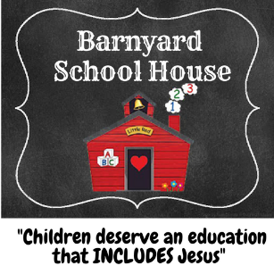

Parental Media Release

As a parent or Guardian of this student _________________________ , I hereby consent to the use of photography/videotape taken during the course of the school year for publicity, promotional and/or educational purposes (including publications , presentation or broadcast via newspaper , internet and other media sources).

I do this with full knowledge and consent and waive all claims for compensation for use, or for damages.
___ Yes, I give consent for Barnyard School House to photograph my child for school purposes and/or at school events.
___ No, I do not authorize Barnyard School House to photograph my child for any event.

Parent Signature: __________________________ Date: ________
Student’s name: ___________________________

